**🧾 Problem Statement**

The call center management team needs a comprehensive, interactive dashboard to monitor overall call performance, agent activities, and customer behavior. The current reporting methods lack clarity, interactivity, and real-time insights into key metrics such as success rates, abandoned calls, agent-wise performance, and customer demographics. The absence of a centralized visual system makes it difficult to identify inefficiencies, analyze reasons for call failures, and understand customer needs.

The objective is to build a professional, visually engaging dashboard that:

* Highlights performance trends and KPIs at a glance.
* Helps monitor agent productivity and call outcomes.
* Allows detailed filtering by agents, time of day, and customer demographics.
* Tracks reasons behind unsuccessful or abandoned calls.
* Provides actionable insights to optimize operations and improve customer service.

**✅ Project Overview**

The Call Center Dashboard project is designed to create an interactive, insightful visualization system that helps the operations and management teams monitor the performance of call center agents, analyze customer behavior, and track overall call outcomes. The dashboard will serve as a decision-making tool, helping the business improve efficiency, enhance customer experience, and reduce call failures.

**🎯 Objective**

The primary objective of this project is to build a user-friendly, professional, and data-driven dashboard that:

* Presents clear and actionable insights from call center data.
* Monitors agent performance using real-time KPIs.
* Tracks call outcomes, including success, failure, and abandonment.
* Helps identify operational gaps and customer service pain points.
* Enables filtering by agent, time of day, customer demographics, and more.

**❗ Problem Statement**

The current reporting process in the call center lacks interactivity, clarity, and flexibility, making it difficult for decision-makers to:

* Monitor agent performance in real-time.
* Identify reasons for call failures or abandonment.
* Understand the distribution of calls across locations, genders, and times of the day.
* Visualize trends in call volumes and performance over time.

As a result, the management team faces challenges in making timely, data-informed decisions to enhance customer satisfaction and internal efficiency.

To overcome this, an interactive dashboard is required that consolidates key metrics, provides drill-down filters, and reveals insights on agents, customers, and call outcomes.

**📊 Key Performance Indicators (KPIs)**

**🔹 Call Performance Metrics**

* **Total Calls**
* **Successful Calls**
* **Failed Calls**
* **Abandoned Calls**

**🔹 Agent Performance Metrics**

* **Total Calls by Agent (Top 5)**
* **Agent Success Rate**
* **Average Call Duration**
* **Agent Rating**

**🔹 Customer Insights**

* **Total Calls from Males**
* **Total Calls from Females**
* **Top 5 States from Where Calls Came**
* **Customer Income Bracket** *(Optional segmentation)*

**🔹 Product & Call Details**

* **Product Discussed on Calls**
* **Follow-Up Call Required Count**

**🔹 Call Behavior & Trends**

* **Call Volume by Time of Day (Morning, Afternoon, Evening)**
* **Monthly Call Trend**

**🔹 Abandonment Insights**

* **Top Reasons for Call Abandonment**

**🧱 Data Model Explanation**

|  |  |  |  |  |  |  |  |  |  |  |  |  |  |  |  |  |  |  |  |  |  |  |  |  |  |  |  |  |  |  |  |  |  |  |  |  |
| --- | --- | --- | --- | --- | --- | --- | --- | --- | --- | --- | --- | --- | --- | --- | --- | --- | --- | --- | --- | --- | --- | --- | --- | --- | --- | --- | --- | --- | --- | --- | --- | --- | --- | --- | --- | --- |
| |  |  | | --- | --- | | **Field Name** | **Used For** | | **Call_ID** | Unique identifier for analysis and tracking | | **Date** | For tracking monthly trends and calling time | | **Agent_First_Name** | To identify and filter by agent | | **Agent_Last_Name** | To identify and filter by agent | | **Agent_Rating** | To analyze agent performance | | **Product_Discussed** | Used in product insights | | **Call_Duration_Minutes** | Calculated as average call duration per agent/customer | | **Call_Outcome** | Determines success, failure, and abandonment metrics | | **Customer_Age** | (Optional segmentation) | | **Callers_Name** | (Optional, not usually visualized) | | **Customer_Gender** | For gender-based call insights | | **State** | Used for geographical segmentation (Top 5 states) | | **Customer_Income_Bracket** | (Optional segmentation) | | **Time_of_Day** | To segment by morning, afternoon, evening | | **Follow_Up_Call_Required** | To calculate follow-up requirement rate | | **Repeat_Customer** | (Optional insight into loyalty or behavior) | | **Reason_Call_Abandoned** | Used in abandonment reason analysis | |

**🧱 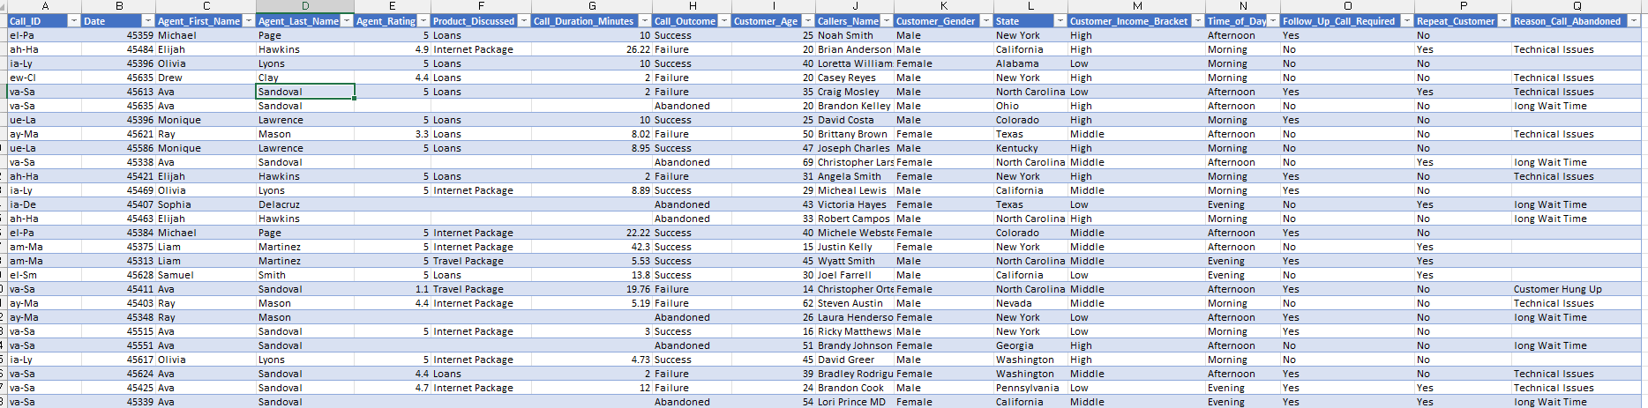Sample Datasets**

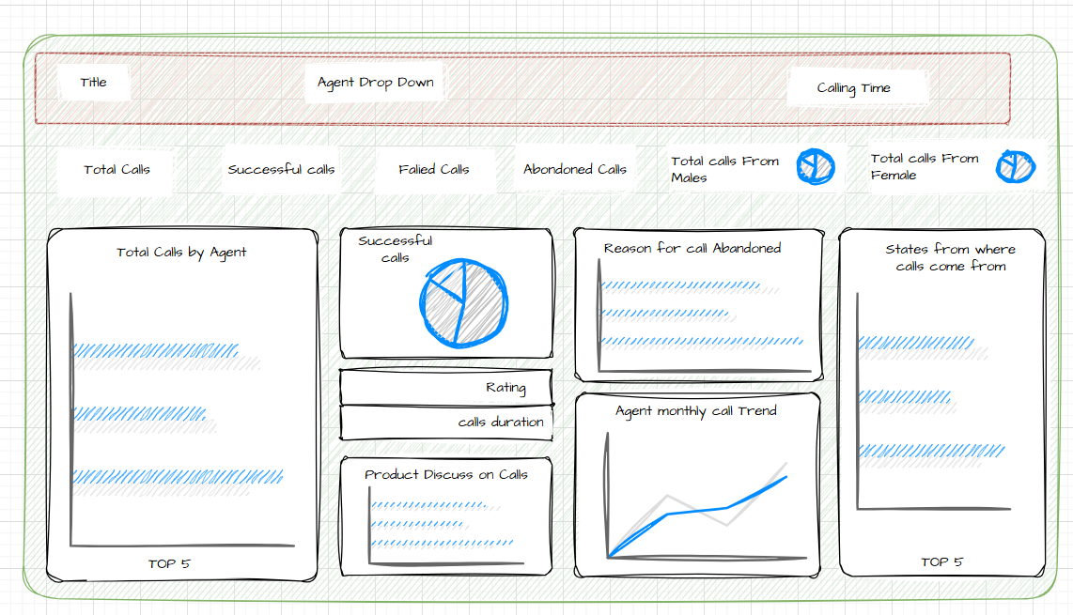**Mock UP**

**Data Transformation:**

**Full name** using CONCAT Function

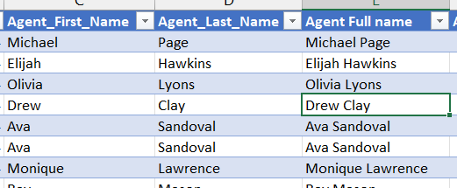

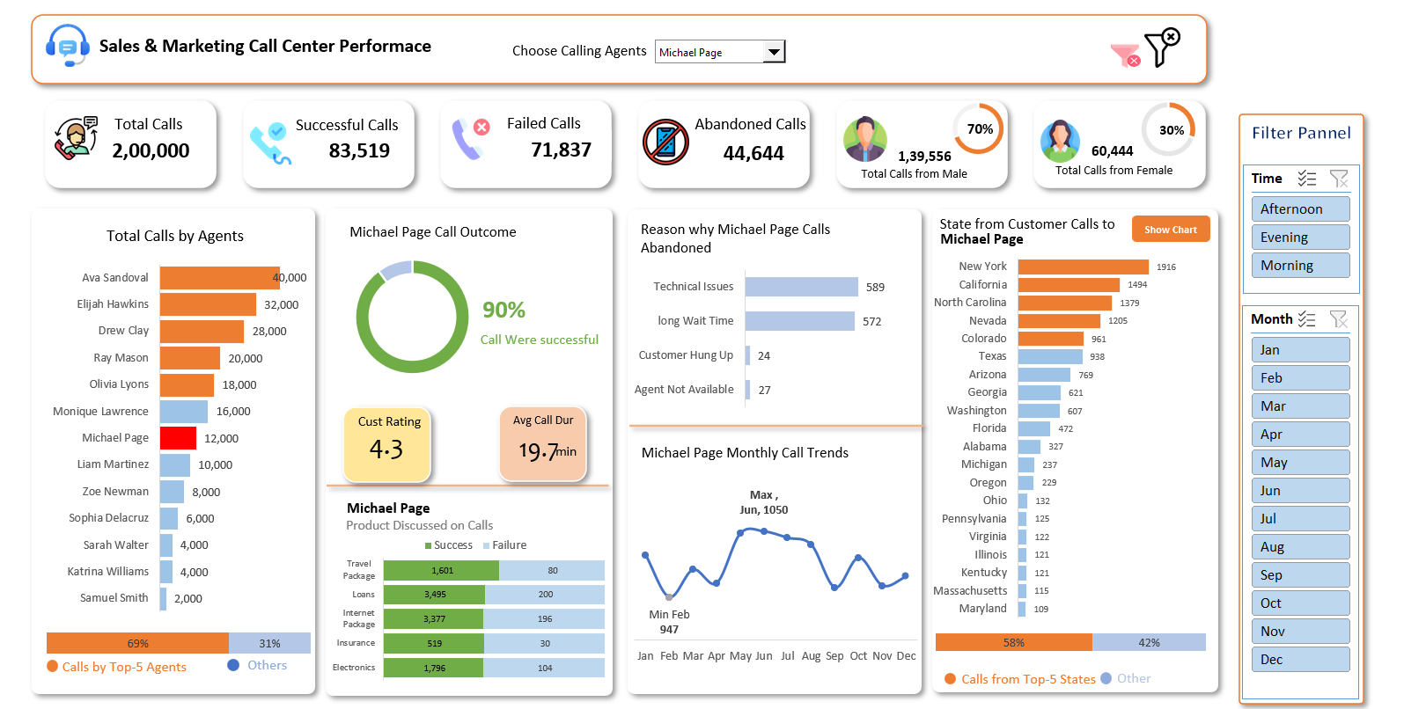

**🎥 Script: Call Center Dashboard Showcase Video**

**[Opening Scene: Upbeat music, visuals of a busy call center with agents on headsets, customers calling, and a manager looking stressed at scattered reports]**

**Narrator (Energetic and Professional Tone):**  
"Imagine running a call center where every day feels like a race against time. Your agents are working hard, customers are calling non-stop, but you’re struggling to keep up. Why? Because your current reporting system is a mess—lacking clarity, interactivity, and real-time insights."

**[Cut to: A frustrated manager flipping through papers, then a screen showing outdated, static charts]**

**Narrator (Problem-Focused Tone):**  
"Without a clear view of your call center’s performance, you can’t spot inefficiencies, understand why calls are failing, or even know what your customers really need. The result? Missed opportunities, frustrated customers, and a team that’s always playing catch-up."

**[Transition: Screen fades to black, then a bright light reveals the Call Center Dashboard with the title 'Sales & Marketing Call Center Performance']**

**Narrator (Excited Tone):**  
"But what if you could change all that with a single, powerful tool? Introducing the *Sales & Marketing Call Center Performance Dashboard*—a game-changer designed to bring clarity, control, and actionable insights right to your fingertips!"

**[Scene: A smooth zoom-in on the dashboard’s top section—Total Calls (2,000,000), Successful Calls (83,519), Failed Calls (71,837), and Abandoned Calls (44,644)]**

**Narrator (Confident Tone):**  
"With this dashboard, you can instantly see the big picture. Track key metrics like Total Calls, Successful Calls, Failed Calls, and Abandoned Calls—all at a glance. In this case, we’ve handled 2 million calls, but 44,644 were abandoned. That’s a red flag we can’t ignore!"

**[Cut to: Zoom-in on the 'Total Calls by Agents' bar chart, highlighting Ava Sandoval (40,000 calls) and Michael Page (12,000 calls)]**

**Narrator (Engaging Tone):**  
"Want to know how your agents are performing? The dashboard breaks it down for you. Ava Sandoval is leading with 40,000 calls, while Michael Page has handled 12,000. But here’s the kicker—69% of all calls are handled by the top 5 agents. Is your team balanced, or is it time to redistribute the workload?"

**[Scene: Focus on the 'Michael Page Call Outcome' donut chart (90% successful) and 'Avg Call Duration' (19.7 min)]**

**Narrator (Insightful Tone):**  
"Let’s zoom in on an agent—Michael Page. His calls are 90% successful, with an average duration of 19.7 minutes. Plus, customers rate him a solid 4.3 out of 5. But what’s causing those 10% unsuccessful calls?"

**[Cut to: 'Reason Why Michael Page Calls Abandoned' bar chart—Technical Issues (589), Long Wait Time (572)]**

**Narrator (Analytical Tone):**  
"The dashboard reveals the reasons behind abandoned calls. For Michael, 589 calls were dropped due to technical issues, and 572 because of long wait times. Now you know exactly where to focus—fix those technical glitches and reduce wait times to keep customers happy!"

**[Scene: Zoom-in on the 'State from Customer Calls to Michael Page' bar chart—New York (1,494), North Carolina (1,379)]**

**Narrator (Curious Tone):**  
"Who’s calling Michael? Most of his calls come from New York and North Carolina, with 58% from the top 5 states. Plus, 70% of his callers are male, and 30% are female. This demographic insight helps you tailor your services to your audience."

**[Cut to: 'Michael Page Monthly Call Trends' line chart, showing a dip in February (947 calls) and a peak in June (1,050 calls)]**

**Narrator (Trend-Focused Tone):**  
"Trends matter too. Michael’s call volume dipped to 947 in February but peaked at 1,050 in June. With this monthly trend view, you can spot patterns and plan resources better—maybe June needs extra support next year!"

**[Scene: Show the 'Product Discussed on Calls' table—Travel (1,602), Loans (3,495), Package (3,377)]**

**Narrator (Practical Tone):**  
"What are customers talking about? The dashboard tracks products discussed on calls. Loans and Packages are hot topics, with 3,495 and 3,377 mentions. This data can guide your marketing team to focus on what customers care about most."

**[Cut to: Filter panel on the right—Time of Day (Morning, Afternoon, Evening) and Months (Jan-Dec)]**

**Narrator (Empowering Tone):**  
"And the best part? You’re in control. Filter by agent, time of day, or month to drill down into the details. Want to see how Michael performs in the evening? Or how the team did in March? It’s just a click away."

**[Closing Scene: A split-screen of a stressed manager (before) and a confident manager using the dashboard (after), with the dashboard prominently displayed in the background]**

**Narrator (Inspirational Tone):**  
"This Call Center Dashboard isn’t just a tool—it’s your partner in success. It helps you monitor performance, uncover inefficiencies, and delight your customers like never before. Ready to transform your call center operations? Let’s make data-driven decisions that drive results!"

**[Outro: Screen shows text 'Sales & Marketing Call Center Performance Dashboard | Optimize. Analyze. Succeed.' with soft background music fading out]**

**Narrator (Warm Tone):**  
"Like what you see? Drop a comment, share this video, and let’s talk about how this dashboard can work for you. Don’t forget to subscribe for more insights!"

**Video Production Notes:**

* **Length:** Aim for 2-3 minutes to keep it concise and engaging for YouTube/LinkedIn audiences.
* **Visuals:** Use screen recordings of the dashboard with smooth zoom-ins on each section as mentioned. Add animations for transitions (e.g., fading, sliding) to keep the video dynamic.
* **Voiceover:** Use a professional, confident voice with varying tones (energetic for the intro, analytical for insights, inspirational for the closing).
* **Background Music:** Choose an upbeat, modern instrumental track that doesn’t overpower the narration.
* **Call to Action:** Encourage engagement (likes, comments, shares) and subscriptions at the end.

This script balances storytelling, data highlights, and a professional tone to make your dashboard presentation compelling and shareable on professional platforms like YouTube and LinkedIn.